# Meeting Information

|  |  |
| --- | --- |
| Meeting Name: | Information Modeling Project/FHIM Meeting |
| Date & Time: | September 4, 2015 2:30-4:00 PM ET |
| Location: | Online <https://global.gotomeeting.com/join/783145837> with VOIP or  **Dial** +1 (571) 317-3122, Access Code: 783-145-837 , **Password**: 3446  **Audio PIN**: Shown after joining the meeting, Meeting |

# Attenance

| Name | Organization | Attendance |
| --- | --- | --- |
| **Steve Wagner** | FHA | **X** |
| **Galen Mulrooney** | FHA | **X** |
| **Jay Lyle** | FHA | **X** |
| **Ioana Singureanu** | VHA | **X** |
| **Elisabeth McCool** | VHA | **X** |
| Raisa Ionin | DoD |  |
| Rob McClure | FHA |  |
| Scott Keller | CDC |  |
| David Bass | VHA |  |
| **Stephen Hufnagel** | FHA | **X** |
| **Hamid Jalal** | Organization unknown | **X** |
| Kenneth Salyards | SAMHSA |  |
| Robert Crawford | VA |  |
| **Iona Thraen** |  | **X** |
| **Susan Matney** |  | **X** |
| **Sean Muir** | FHA | **X** |
| **Bill Hess** |  |  |
|  |  |  |
| **John Weiser** | DoD | **X** |
| Rowell Pasion | Organization unknown |  |
| **Håkan Lidström** | FHA | **X** |

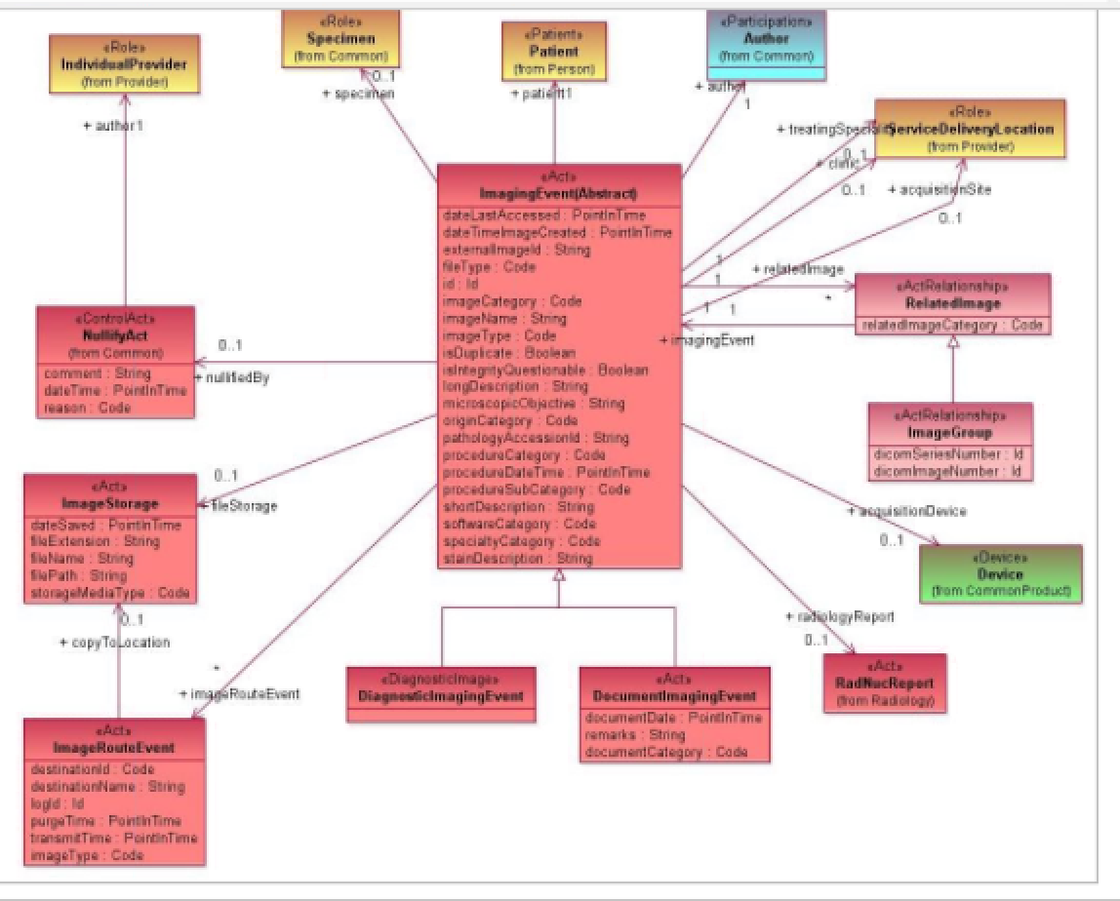

Figure 1 FHIM Radiology Model

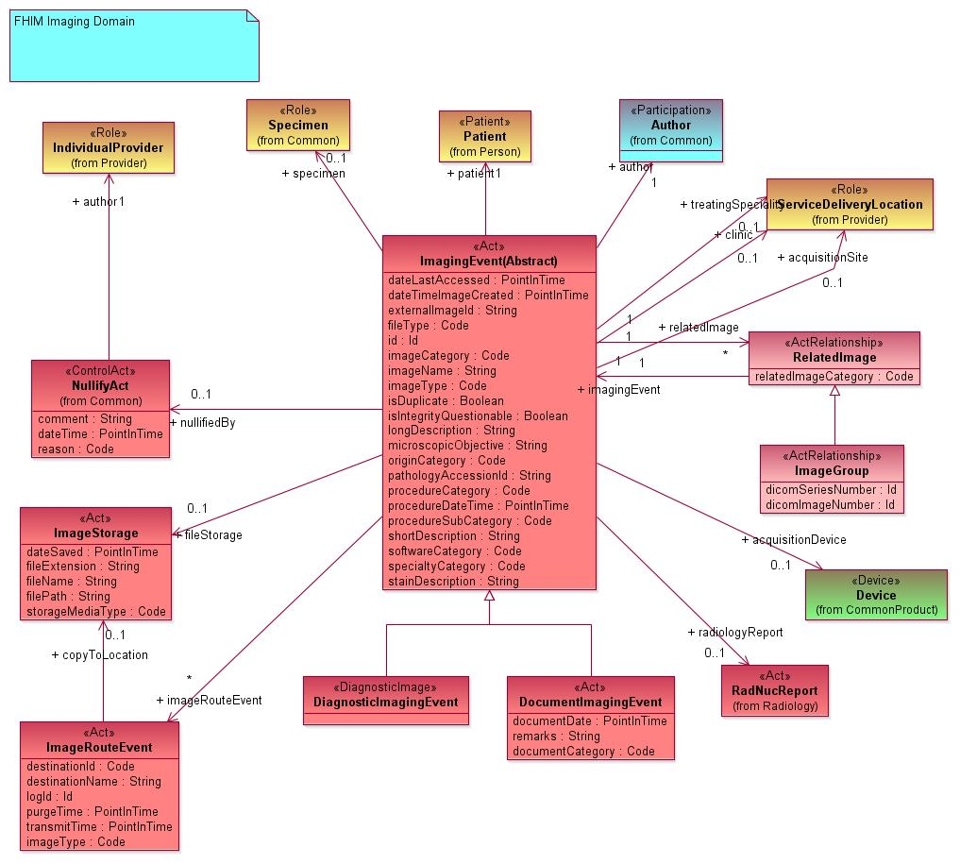

Figure 2 FHIMS Imaging Model

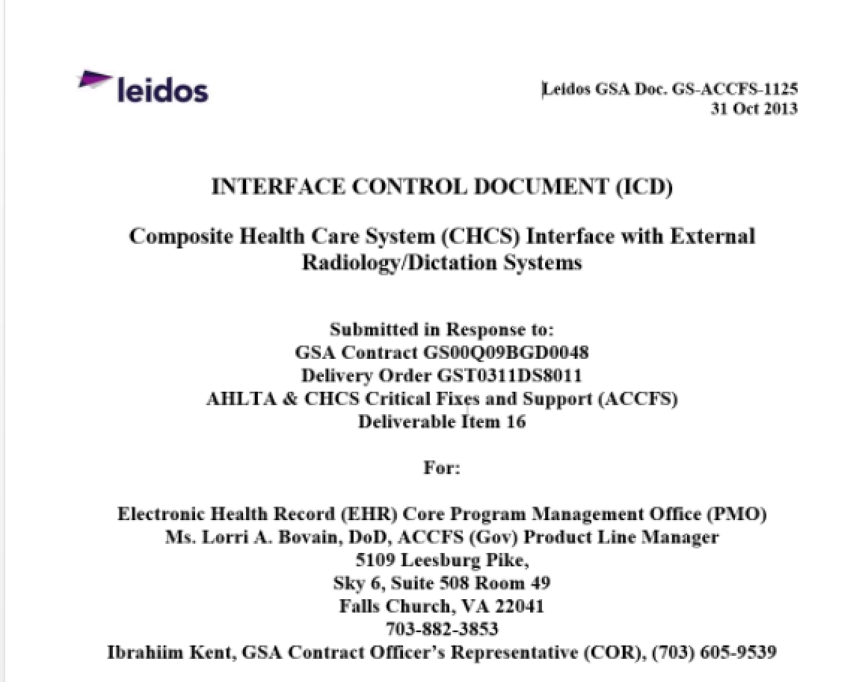

Figure 3 CHCS ICD

# Summary

## Update on S&I and FHA Initiatives, Etc. (*Steve Wagner*)

No updates

## Terminology Modeling Update and Discussion (*Jay Lyle*)

Work has resumed on Care Plan

## Modeling the Radiology Domain (*Galen Mulrooney*)

# Radiologic exam

* After several months of inactivity, we restarted modeling the Radiology Domain
* We are still a few weeks from finishing Radiology; where, we have done:
* Order, promise and Result
* Currently we differentiate Figure 1 FHIM Radiology Model and Figure 2 FHIMS Imaging Model, which are joined in the VA model.
* The importance of the DICOM standards for radiology was pointed out and also that IHE standards (e.g., XDS) apply.
* **ISSUE**:
  + Dose Management System (from CT scanner / XRay systems) needs to be considered.
  + IHE workflow need to be considered
  + Procedure tables should be standardized using NLM’s LexRad and/or SNOMED extension for US Realm managed by NLM; where, Cerner may be using the Intermountain codes
    - This is a potential DHMSM/Cerner issue.
* **SCOPE:** 
  + EHR & PAC system interoperability
  + Transfer of information between EHRs
  + Ordering and Resulting of exams
  + Doing FHIR alignment and IHE alignment
  + 3M HDD sub under Leidos [Susan Matney]

# Next Meeting

Friday, September 11, 2015 at 2:30 PM, EDT

# Action Items

| Action Item Description | Responsible | Due Date |
| --- | --- | --- |
| No new actions |  |  |
|  |  |  |

# FHIM Information and Terminology Modeling Calls

## Information Modeling (IM) project calls (Every Friday)

Time of Calls: 2:30 to 4:30 PM Eastern Time  
<https://global.gotomeeting.com/join/947006365>  
Use your microphone and speakers (VoIP) - a headset is recommended.  
Or, call in using your telephone.  
Dial +1 (646) 749-3131  
Access Code: 947-006-365  
Audio PIN: Shown after joining the meeting.

## Terminology Modeling calls (Every Wednesday)

Time of Calls: 2:00 to 3:30 PM Eastern Time  
<https://global.gotomeeting.com/join/947006365>  
Use your microphone and speakers (VoIP) - a headset is recommended.  
Or, call in using your telephone.  
Dial +1 (646) 749-3131  
Access Code: 947-006-365  
Audio PIN: Shown after joining the meeting.

## FHA Health Information Modeling WG (2’nd Tuesday each month)

Next meeting: May 12 at 1 PM Eastern Time

Time of Calls: 1:00 to 2:00 PM Eastern Time  
<https://www3.gotomeeting.com/register/267621646>

Use your telephone for audio.  
Dial + 1-888-537-7715 Code: 2734 4310#